Linear regression
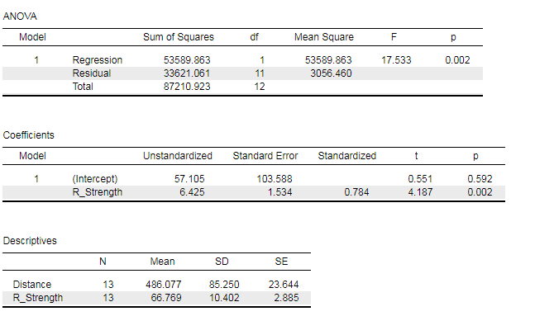
Bayesian linear regression
